**VIVEKANAND EDUCATION SOCIETY’S INSTITUTE OF TECHNOLOGY**

**(An Autonomous Institute Affiliated to University of Mumbai**

**Department of Computer Engineering)**

**Department of Computer Engineering**



**Project Report on**

# PlaceNext: “A Gateway to Career Opportunities”

Submitted in partial fulfillment of the requirements of Third Year (Semester–VI), Bachelor of Engineering Degree in Computer Engineering at the University of Mumbai Academic Year 2024-25

By

Mrunal Mahajan (41)

Madhura Anerao(06)

Latish Adwani(01)

Ayush Verma(61)

Name of the Mentor

**Prof. Sanjay Mirchandani**

**University of Mumbai**

**(AY 2024-25)**

**VIVEKANAND EDUCATION SOCIETY’S INSTITUTE OF TECHNOLOGY**

**(An Autonomous Institute Affiliated to University of Mumbai**

**Department of Computer Engineering)**

**Department of Computer Engineering**



**CERTIFICATE**

This is to certify that **Mrunal Mahajan (41), Ayush Verma(61) , Latish Adwani(01), Madhura Anerao(06)** of Third Year Computer Engineering studying under the University of Mumbai has satisfactorily presented the project on “**PlaceNext: A Gateway to Career Opportunities**” as a part of the coursework of Mini Project 2B for Semester-VI under the guidance of **Prof. Sanjay Mirchandani** in the year 2024-25.

______***_______________***

Date

| __________________ |  | __________________ |
| --- | --- | --- |
| Internal Examiner |  | External Examiner |

_________________ __________________ __________________

Project Mentor Head of the Department Principal

**Prof. Sanjay Mirchandani** **Dr. Mrs. Nupur Giri** **Dr. J. M.** Nair

**Declaration**

We declare that this written submission represents our ideas in our own words and where others' ideas or words have been included, we have adequately cited and referenced the original sources. We also declare that we have adhered to all principles of academic honesty and integrity and have not misrepresented or fabricated or falsified any idea / data / fact / source in our submission. We understand that any violation of the above will be cause for disciplinary action by the Institute and can also evoke penal action from the sources which have thus not been properly cited or from whom proper permission has not been taken when needed.

| -----------------------------------------  (Signature)  -----------------------------------------  (Name of student and Roll No.) | -----------------------------------------  (Signature)  -----------------------------------------  (Name of student and Roll No.) |
| --- | --- |
| -----------------------------------------  (Signature)  -----------------------------------------  (Name of student and Roll No.) | -----------------------------------------  (Signature)  -----------------------------------------  (Name of student and Roll No.) |

Date:

## ACKNOWLEDGEMENT

We are thankful to our college Vivekanand Education Society’s Institute of Technology for considering our project and extending help at all stages needed during our work of collecting information regarding the project.

It gives us immense pleasure to express our deep and sincere gratitude to Assistant Professor **Prof. Sanjay Mirchandani** (Project Guide) for her kind help and valuable advice during the development of project synopsis and for her guidance and suggestions.

We are deeply indebted to Head of the Computer Department **Dr.(Mrs.) Nupur Giri** and our Principal **Dr. (Mrs.) J.M. Nair ,** for giving us this valuable opportunity to do this project.

We express our hearty thanks to them for their assistance without which it would have been difficult in finishing this project synopsis and project review successfully.

We convey our deep sense of gratitude to all teaching and non-teaching staff for their constant encouragement, support and selfless help throughout the project work. It is a great pleasure to acknowledge the help and suggestion, which we received from the Department of Computer Engineering.

We wish to express our profound thanks to all those who helped us in gathering information about the project. Our families too have provided moral support and encouragement several times.

### Computer Engineering Department

**COURSE OUTCOMES FOR T.E MINI PROJECT 2B**

Learners will be to:-

| **CO No.** | **COURSE OUTCOME** |
| --- | --- |
| CO1 | Identify problems based on societal /research needs. |
| CO2 | Apply Knowledge and skill to solve societal problems in a group. |
| CO3 | Develop interpersonal skills to work as a member of a group or leader. |
| CO4 | Draw the proper inferences from available results through theoretical/ experimental/simulations. |
| CO5 | Analyze the impact of solutions in societal and environmental context for sustainable development. |
| CO6 | Use standard norms of engineering practices |
| CO7 | Excel in written and oral communication. |
| CO8 | Demonstrate capabilities of self-learning in a group, which leads to lifelong learning. |
| CO9 | Demonstrate project management principles during project work. |

**Index**

**Title page no.**

**Abstract**

**Chapter 1: Introduction**

1.1 Introduction

1.2 Motivation

1.3 Problem Definition

1.4 Existing Systems

1.5 Lacuna of the existing systems

1.6 Relevance of the Project

**Chapter 2: Literature Survey**

A. Overview of Literature Survey

B. Related Works

2.1 Research Papers Referred

a. Abstract of the research paper

b. Inference drawn

2.2 Patent search

2.3. Inference drawn

2.4 Comparison with the existing system

**Chapter 3: Requirement Gathering for the Proposed System**

3.1 Introduction to requirement gathering

3.2 Functional Requirements

3.3 Non-Functional Requirements

3.4.Hardware, Software , Technology and tools utilized

3.5 Constraints

**Chapter** 4**: Proposed Design**

4.1 Block diagram of the system

4.2 Modular design of the system

4.3 Detailed Design

4.4 Project Scheduling & Tracking : Gantt Chart

**Chapter 5: Implementation of the Proposed System**

5.1. Methodology Employed

5.2 Algorithms and flowcharts

5.3 Dataset Description

**Chapter 6: Testing of the Proposed System**

6.1. Introduction to testing

6.2. Types of tests Considered

6.3 Various test case scenarios considered

6.4. Inference drawn from the test cases

**Chapter 7: Results and Discussion**

7.1. Screenshots of User Interface (GUI)

7.2. Performance Evaluation measures

7.3. Input Parameters / Features considered

7.4. Graphical and statistical output

7.5. Comparison of results with existing systems

7.6. Inference drawn

**Chapter 8: Conclusion**

8.1 Limitations

8.2 Conclusion

8.3 Future Scope

**References**

**Abstract**

## Introduction

* 1. **Introduction** :

In today’s highly competitive job market, campus placements play a pivotal role in shaping the future careers of students. However, the conventional methods of conducting placements in academic institutions are often riddled with inefficiencies, lack of coordination, and manual intervention. Training and Placement Officers (TPOs) struggle with organizing data, tracking metrics, and communicating effectively with students and companies. Similarly, students frequently miss crucial updates, face difficulties in aligning their resumes with job roles, and lack access to proper preparation tools. Companies, on the other hand, find it challenging to filter candidates based on evolving job requirements.

To bridge these gaps, *PlaceNext: A Gateway to Career Opportunities* is conceptualized as an innovative campus placement platform that automates and optimizes the placement process. The platform is designed to serve the three main stakeholders—students, TPOs, and companies—through a suite of smart features including dynamic profile management, job and interview scheduling, analytics dashboards, AI-driven resume analysis, and a chatbot for placement-related queries. With its data-driven approach and focus on user experience, PlaceNext transforms the campus placement ecosystem into an efficient, transparent, and responsive process.

* 1. **Motivation :**

The motivation behind the development of PlaceNext stems from the observed shortcomings and pain points in the existing campus recruitment processes. In many institutions, placements are still managed through spreadsheets, email chains, and manual filtering. This not only delays the process but also leads to inconsistencies, missed opportunities, and lack of proper insights.

* Students missing deadlines due to poor communication.
* Companies facing difficulty in evaluating candidate suitability from static resumes.
* TPOs spending time on routine coordination instead of focusing on strategy.
* A general lack of personalized guidance and preparation materials for students.  
  1. **Problem Statement & Objectives :**

The conventional campus placement system lacks automation, analytical insights, and intelligent features required to efficiently manage the recruitment lifecycle for students, TPOs, and companies. There is a pressing need for a centralized digital platform that not only facilitates the end-to-end placement process but also enhances engagement, decision-making, and outcome optimization for all stakeholders involved.

#### Objectives:

The primary objective of this project is to design and develop a comprehensive campus placement platform with the following goals:

* To automate and streamline the end-to-end placement process.
* To enable real-time resume updates and intelligent resume-job matching.
* To provide dashboards and analytics for TPOs to monitor placement trends.
* To allow companies to post jobs, schedule interviews, and evaluate candidates.
* To offer students preparation tools, feedback mechanisms, and performance tracking.
* To build an AI-powered chatbot that assists in resolving placement-related queries.
* To facilitate a notification and alert system for timely communication.
* To bridge the gap between candidate skills and job requirements through resume enhancement features.

**1.4 Existing System :**

In most educational institutions today, campus placement processes are managed using basic digital tools or third-party software platforms. Commonly adopted systems include:

* Google Forms and Spreadsheets for student data collection and company registration.
* Email threads for communication and notification purposes.
* Third-party platforms such as TCS iON, Superset, or HireMee for job application tracking.
* Manual filtering of candidates based on eligibility criteria by faculty and TPOs.
* Static resume submissions through limited document upload systems.

**1.5 Lacuna of the existing systems :**

* **Data Redundancy & Inconsistency** : Students have to fill multiple forms for different companies, leading to repeated data entry, human errors, and lack of centralized data.
* **Manual Candidate Filtering** : TPOs often manually verify eligibility, which is time-consuming and error-prone, especially for large batches.
* **Lack of Smart Resume Matching** : Existing systems accept static resumes and do not evaluate how well a candidate fits the job based on content.
* **No Personalized Recommendations** : Students are not guided towards the most suitable jobs; there are no intelligent job matching or recommendation systems.
* **Communication Gaps** : Reliance on email results in missed deadlines and opportunities. Notifications are not real-time or personalized.
* **Limited Analytics and Dashboards** : TPOs and faculty lack live dashboards to track placement trends, selections, and job performance metrics.
* **No Integrated Learning or Preparation Tools** : Interview preparation resources, such as mock tests or company-specific materials, are not provided or integrated into these platforms.

## 1.6 Relevance of the Project

The campus placement process is a critical phase in a student’s academic journey, significantly impacting their career trajectory. However, despite its importance, most institutions still rely on manual processes, basic digital tools, or rigid third-party platforms, which result in inefficiencies, delays, and missed opportunities.

In this context, the PlaceNext platform is highly relevant as it aligns with the growing need for digital transformation in the education and recruitment ecosystem. It addresses the pain points faced by students, Training and Placement Officers (TPOs), and companies, offering a unified, intelligent, and automated solution.

### Key Reasons for Relevance:

1. **Bridging Communication Gaps:** Timely and targeted notifications reduce missed deadlines and improve engagement across all stakeholders.
2. **Smart Job Matching:** AI-powered resume analysis and job recommendations help students apply for roles that match their skills and interests.
3. **Reduced Manual Workload**: Automating resume filtering, candidate shortlisting, and interview scheduling helps TPOs focus on strategic placement activities.
4. **Data-Driven Decision Making:** Real-time dashboards and analytics allow institutes to monitor placement trends, student performance, and recruiter demands effectively.
5. **Skill Enhancement & Readiness**: Integrated tools for mock interviews, aptitude tests, and feedback mechanisms prepare students thoroughly for the recruitment process.

# 

# Chapter 2: Literature Survey

## A. Overview of Literature Survey

The literature survey conducted for PlaceNext: A Gateway to Career Opportunities focused on understanding existing placement systems, their limitations, and potential areas for innovation. This survey examined several research papers related to campus placement automation, AI-driven recruitment, and student eligibility verification. Additionally, it investigated existing systems to identify gaps that could be addressed by our proposed solution. The survey aimed to establish a solid foundation for the development of PlaceNext by learning from previous work while identifying opportunities for meaningful enhancement.

## B. Related Works

### 2.1 Research Papers Referred

#### a. Abstract of the research papers

**1. Sahare, Swati et al. (2023). "Online Training and Placement System."**

This research discusses the development of an online training and placement system designed to automate the campus recruitment process. The authors focus on creating a centralized platform that enables efficient communication between students, training and placement officers, and recruiting companies. The paper highlights how automation can reduce manual workload and improve data management in institutional placement activities.

**2. Karbhari, N. et al. (2017). "Recommendation system using content filtering: A case study for college campus placement."**

This paper presents a recommendation system that uses content filtering techniques specifically designed for campus placement scenarios. The authors demonstrate how analyzing student profiles against job requirements can lead to more personalized job recommendations. The system aims to match students with appropriate job opportunities based on their skills, academic performance, and career interests.

**3. Sinthuja, M. et al. (2023). "Integrated Webapp For Campus Placement."**

The authors propose an integrated web application for campus placement that combines student data management, company interactions, and placement tracking. The research emphasizes the importance of a unified platform approach as opposed to fragmented systems. The paper discusses implementation techniques and the benefits of web-based accessibility.

**4. Rajkumar, V. Samuel et al. (2015). "Analysis of Campus Recruitment Parameters in an Indian Context."**

This research analyzes key parameters that influence campus recruitment outcomes in Indian educational institutions. The study identifies critical factors considered by recruiters and how institutions can optimize their placement processes accordingly. The paper provides valuable insights into the metrics that matter most in the campus recruitment ecosystem.

**5. Castillo, J.R. et al. (2013). "Towards improved student placement and preparation methods on information technologies post-secondary education."**

This paper explores methods to improve student placement and preparation, particularly for information technology fields. The authors discuss approaches to better align student skills with industry requirements and suggest preparation strategies to enhance employability.

**6. Shah, Ameet. (2023). "Inter-Linked Platform for Campus Placement in Higher educational Institutions of India."**

The research proposes an inter-linked platform connecting various stakeholders in the campus placement process. The author emphasizes the need for seamless integration between academic institutions and industry recruiters, with a focus on Indian higher education contexts.

**7. Kamble, Prof et al. (2022). "Campus Recruitment System."**

This paper presents a campus recruitment system framework that addresses key challenges in traditional placement processes. The authors discuss design considerations, implementation approaches, and potential benefits of their proposed system.

**8. Shenoy, Varun and Aithal, P.S. (2016). "Changing Approaches in Campus Placements - A New Futuristic Model."**

The authors explore evolving trends in campus placement approaches and propose a futuristic model that adapts to changing industry requirements and student expectations. The paper discusses how technology can transform traditional placement models into more dynamic and responsive systems.

**9. Agrawal, V.S. & Kadam, S.S. (2024). "Predictive Analysis of Campus Placement of Student Using Machine Learning Algorithms."**

This research focuses on using machine learning algorithms to predict student placement outcomes. The authors demonstrate how data-driven approaches can help identify factors that influence placement success and enable more targeted preparation strategies.

**10. Chaudhari, M. "A Study on Factors Considered by Millennial Management Students While Applying for Job Through Campus Placement."**

The study investigates the key factors that influence millennial management students' decisions when applying for jobs through campus placement processes. The research provides insights into student preferences and priorities that can inform the design of placement platforms.

#### b. Inference drawn

From the reviewed research papers, several key inferences can be drawn:

1. **Automation Need**: There is a clear consensus among researchers about the need to automate the campus placement process to reduce manual workload and improve efficiency.
2. **Data-Driven Decision Making**: Multiple studies highlight the importance of analytics and data-driven approaches in optimizing placement outcomes and tracking performance metrics.
3. **Personalization**: Research indicates that personalized job recommendations and tailored preparation strategies significantly improve student placement success rates.
4. **Communication Gaps**: Several papers identify communication inefficiencies as a major challenge in traditional placement processes, suggesting the need for integrated notification systems.
5. **Skill Alignment**: There is growing recognition of the importance of aligning student skills with industry requirements through targeted preparation and skill enhancement.
6. **Evolving Models**: Campus placement approaches are evolving, with increasing emphasis on digital platforms, AI-driven matching, and comprehensive tracking systems.
7. **Stakeholder Integration**: Successful placement systems require seamless integration between students, TPOs, and companies to create a unified ecosystem.
8. **Predictive Analytics**: Machine learning algorithms show promise in predicting placement outcomes and identifying factors that contribute to successful employment.

### 2.2 Patent search

Based on the provided documents, there is no specific mention of patent searches conducted for this project. This section would typically include relevant patents related to placement systems, automated recruitment tools, or AI-based resume analyzers.

### 2.3. Inference drawn

From the literature survey, several important inferences can be drawn that directly informed the development of PlaceNext:

1. **Manual Processes Dominate**: Despite technological advancements, many institutions still rely on manual processes for placement activities, creating opportunities for automation.
2. **Data Management Challenges**: Existing systems often struggle with data redundancy and inconsistency due to the use of multiple disconnected platforms like Google Forms and spreadsheets.
3. **Communication Inefficiencies**: Email-based communication for placement updates leads to missed opportunities and information gaps.
4. **Limited Analytics**: Current systems lack comprehensive analytics capabilities that could help institutions optimize their placement strategies.
5. **Fragmented Platforms**: The use of multiple company-specific portals creates a fragmented experience for students tracking their applications.
6. **Evolving Requirements**: As industry requirements evolve, placement systems need to become more dynamic and responsive to changing needs.
7. **Personalization Gap**: There is a significant gap in providing personalized job recommendations based on student profiles and company requirements.
8. **AI Potential**: AI and machine learning technologies show significant potential for enhancing various aspects of the placement process, from resume optimization to candidate matching.

### 2.4 Comparison with the existing system

Based on the literature survey and gap analysis, PlaceNext offers several advantages over existing systems:

| **Feature** | **Existing Systems** | **PlaceNext** |
| --- | --- | --- |
| Data Collection | Multiple Google Forms and spreadsheets | Centralized student database with single registration |
| Eligibility Verification | Manual filtering by TPOs | Automated rule-based verification system |
| Communication | Email threads and notice boards | Integrated notification system with real-time alerts |
| Application Process | Repeated form submission for each company | One-time profile creation with automatic application routing |
| Analytics | Limited or basic spreadsheet analysis | Comprehensive dashboards with visual analytics |
| Resume Enhancement | Generic feedback, if any | AI-powered resume analysis and optimization |
| Job Matching | Manual or basic filtering | Intelligent matching based on multiple parameters |
| Preparation Resources | Separate from placement platforms | Integrated preparation tools and resources |
| User Experience | Often fragmented across multiple systems | Unified interface for all placement activities |
| Data Management | Redundant data entry and inconsistencies | Single source of truth with update propagation |
| Scalability | Limited by manual processes | Cloud-based architecture designed for scalability |

PlaceNext addresses the key limitations identified in existing systems by providing an integrated, automated, and intelligent platform that streamlines the entire placement process while delivering valuable insights to all stakeholders. The system's focus on eliminating data redundancy, automating eligibility verification, and enhancing communication represents a significant advancement over traditional placement management approaches.

1. **Literature Survey** 
   1. **Survey of Existing System :**

The survey of existing system for campus placements reveals several challenges and inefficiencies. Many colleges rely on Google Forms and spreadsheets to collect student data and track applications, leading to data redundancy and missed opportunities as students must repeatedly fill forms for each company. Faculty and TPOs spend significant time manually segregating students based on eligibility criteria and sending frequent reminders, increasing their workload. Email-based communication often results in miscommunication or missed notifications, while company-specific portals like TCS iON or Cocubes provide fragmented access to job opportunities and limit data control. Though some institutions use third-party placement software like Superset or HireMee, these platforms are often expensive, inflexible, and not tailored to specific institutional needs. Additionally, the absence of centralized data and real-time statistics makes it difficult for both students and TPOs to track placement trends effectively. “PlaceNext: A Gateway to Career Opportunities” addresses these gaps by offering a centralized data management system with automated candidate filtering, integrated notifications, and real-time dashboards, significantly reducing the manual workload of faculty while enhancing student participation and placement outcomes.

* 1. **Limitation Existing system or Research gap :**

1. Data Redundancy and Inconsistency:Existing systems store student data across multiple Google Forms or spreadsheets, leading to repeated data entry and inconsistencies in records.

2. Manual Candidate Segregation: Faculty and TPOs have to manually filter students based on each company’s eligibility criteria, which is time-consuming and prone to errors.

3. Missed Opportunities for Students: Due to the need to fill separate forms for every company, students often miss applications, reducing their chances of securing placements.

4. Communication Gaps: Email-based reminders and notifications are unreliable, as students may overlook or miss important messages about interviews and deadlines.

5. Limited Insight into Placement Metrics: Existing systems lack automated dashboards to track statistics like the number of jobs applied for, selections, and highest packages, making it difficult for TPOs and students to monitor progress in real-time.

6. Overburdened TPOs and Faculty: The manual processes of sending continuous reminders and managing data increase the workload and stress for TPOs and faculty.

7. Fragmented Platforms and Lack of Centralization: Company-specific portals and third-party placement platforms are not interconnected, making it difficult to manage applications efficiently from a single place.

8. Customization and Cost Issues: Existing third-party software solutions are often expensive and offer limited customization, restricting institutions from tailoring the platform to their specific requirements.

# 3 Requirement Gathering for the Proposed System

## 3.1 Introduction to Requirement Gathering

## Requirement gathering is one of the most critical phases in software development. It involves identifying the needs, expectations, and functionalities required by stakeholders for the proposed system. For *PlaceNext*, requirements were gathered through interaction with Training and Placement Officers (TPOs), students, and faculty members. Additionally, a gap analysis was performed by studying existing systems and identifying the inefficiencies they present.

## The goal of this phase is to establish a clear understanding of what the system must do, the problems it aims to solve, and the constraints it must operate under. This ensures the development of a product that is both technically feasible and functionally useful.

## 3.2 Functional Requirements

## These requirements define the core features and services the system must provide:

## Student Module:

## Registration and secure login/logout

## Resume creation and upload

## Job application and tracking

## Receive notifications and reminders

## TPO Module:

## View student data and analytics

## Set eligibility criteria and shortlist students

## Create and manage job postings

## Monitor placement statistics via dashboards

## Company Module:

## Submit job profiles and requirements

## View shortlisted students

## Schedule interviews and post results

## Admin/Backend:

## Manage user roles (student, TPO, company)

## Maintain system logs and backups

## Access overall analytics and data reports

## AI Chatbot Module:

## Answer placement-related queries

## Guide students through the platform features

## Resume Analyzer Module:

## Match student resume with job description

## Provide a match percentage and improvement suggestions

## 3.3 Non-Functional Requirements

## These specify how the system should behave and the qualities it should have:

## Performance: The system should support at least 1000 concurrent users without noticeable lag.

## Reliability: The system should ensure 99% uptime with proper error handling.

## Scalability: Designed to easily scale with increasing number of users and institutions.

## Security: All user data should be encrypted; sensitive actions require authentication.

## Usability: The interface should be intuitive and accessible to both technical and non-technical users.

## Maintainability: The codebase should follow modular and reusable design principles for easy updates.

## Portability: The system should be compatible across major browsers and devices.

**3.4 Hardware & Software Specifications:**

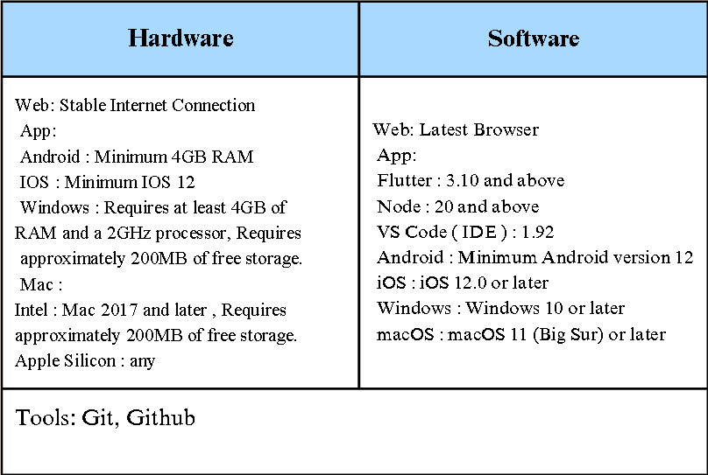

**3.5 Constraints**

## Time Constraint: Limited semester duration restricts the inclusion of certain advanced features like ML-based predictions.

## Data Access Constraint: Limited access to real placement data due to privacy policies.

## Team Size: With a small team, multitasking between development, testing, and documentation is challenging.

## Dependency on Internet: As a cloud-based platform, PlaceNext requires stable internet connectivity to function properly.

**Chapter 4: Proposed Design**

**4.1 Block diagram of the system**

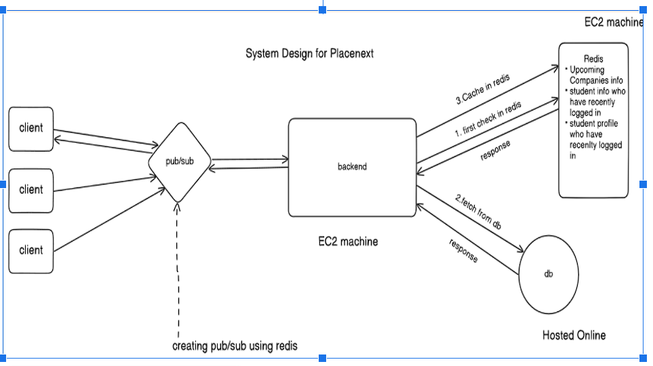

**Fig 3.2.1 : System Design**

The **PlaceNext: A Gateway to Career Opportunities architecture** consists of the following components:

1. **Clients**: Multiple users (students, companies, admins) interact with the system.
2. **Pub/Sub System**: Redis-based publish/subscribe mechanism manages client requests and forwards them to the backend.
3. **Backend (EC2)**: Central processing unit that handles client requests, checks Redis for cached data, and queries the database when necessary.
4. **Redis (Cache)**: Stores frequently accessed data (like upcoming companies and recently logged-in students) to reduce database load and improve response time.
5. **Database (Hosted Online)**: Stores all persistent data such as student profiles and placement records. It is accessed when data is not found in Redis.

**4.2 Modular design of the system**

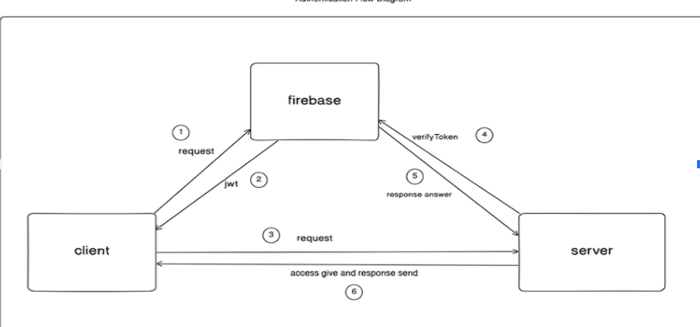

**Fig 3.4.1 Client-Server Interaction with Firebase Token Authentication**

This diagram illustrates a basic interaction where the client requests authentication from Firebase (Step 1), receives a JWT token (Step 2), and then forwards a request to the server with the token (Step 3). The server verifies the token with Firebase (Step 4) before responding to the client with the requested data or access (Steps 5 and 6).

## 4.3 Detailed Design

The detailed design of PlaceNext elaborates on the interactions between various system components and the data flow across modules.

### Authentication Flow:

1. Client requests authentication from Firebase service
2. Firebase validates credentials and issues JWT token
3. Client includes token in all subsequent requests to server
4. Server verifies token validity with Firebase before processing requests
5. On successful verification, server responds with requested data or access
6. For invalid or expired tokens, server returns authentication error

### Student Process Flow:

The student journey through the system follows a structured path:

1. Student logs in to the system using secure credentials
2. Student completes profile and uploads required documents
3. System verifies student information for completeness
4. If information is correct, TPO approves student profile
5. Student gains access to job listings filtered by eligibility
6. Student can apply to relevant positions
7. System tracks application status and provides updates

### Company Process Flow:

Companies interact with the system through the following workflow:

1. Company contacts TPO to request job posting
2. TPO creates job listing with detailed requirements
3. TPO sets eligibility criteria for the position
4. System filters students based on eligibility rules
5. Eligible students can view and apply to the position
6. TPO verifies applicant list for final eligibility
7. Verified list is sent to company for review

### Data Flow Architecture:

1. Client applications (Next.js and Flutter) serve as the presentation layer
2. RESTful APIs handle data exchange between clients and backend
3. Firebase manages authentication and real-time capabilities
4. Node.js and Express handle business logic processing
5. MongoDB stores and retrieves structured data
6. Redis caches frequently accessed information

### Database Schema Design:

The database design includes collections for:

* Users (with role-based attributes)
* Student Profiles (academic records, skills, projects)
* Company Profiles (company details, contact information)
* Job Postings (requirements, eligibility criteria, deadlines)
* Applications (status tracking, feedback, timestamps)
* Notifications (recipients, content, status)
* System Logs (for audit and troubleshooting)

**4.4 Project Scheduling & Tracking : Gantt Chart**

**Chapter 5: Implementation of the Proposed System**

**5.1. Methodology Employed**

**5.2 Algorithms and flowcharts**

**Student process flow:**

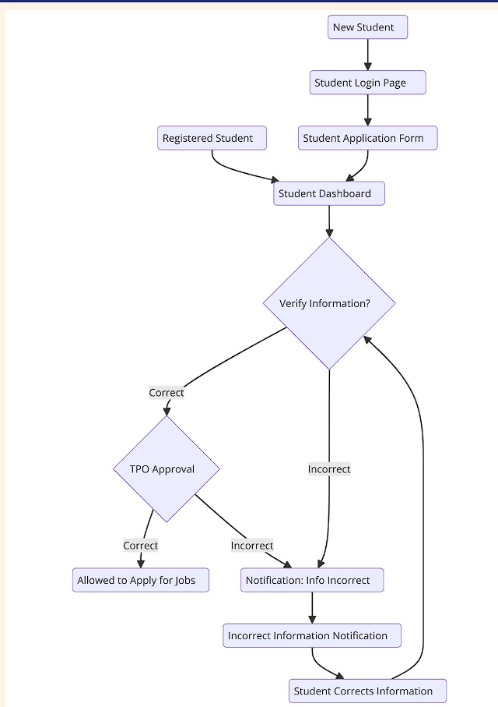

**Fig 3.3.1 Student Process Flow**

The flowchart depicts the student job application process within a placement system. After logging in and filling out the application form, students verify their information. If correct, the Training and Placement Officer (TPO) approves their eligibility to apply for jobs. If incorrect, the student is notified and prompted to correct the information before proceeding.

**company process flow:**

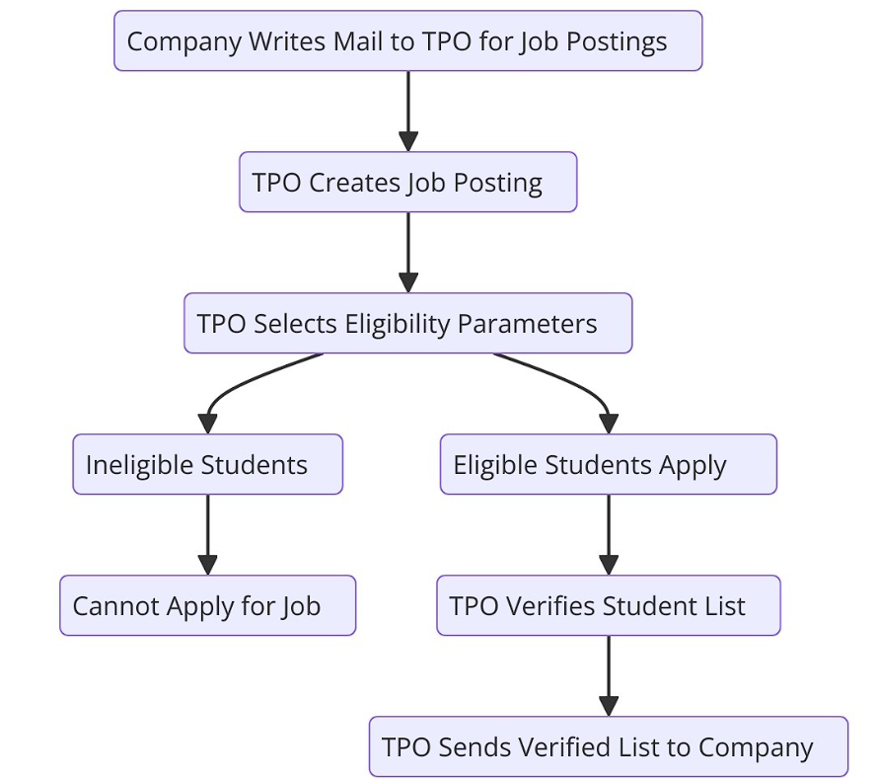

**Fig 3.3.2 Company Process Flow**

The figure depicts the “Company Process Flow” for job recruitment through the Training and Placement Officer (TPO). It begins with a company requesting job postings from the TPO, who then creates the job posting and sets eligibility criteria. Eligible students apply, and their applications are verified by the TPO. The verified list of students is then sent back to the company for further consideration, while ineligible students are excluded from applying.

**5.3 Dataset Description**

# Chapter 6: Testing of the Proposed System

## 6.1. Introduction to testing

Testing is a critical phase in the development lifecycle of PlaceNext to ensure the system functions reliably, securely, and efficiently. The testing strategy for PlaceNext was designed to validate all functional components across the three user interfaces (student, TPO, and company) while also ensuring non-functional requirements like performance, security, and usability were met.

Testing was conducted in a phased approach, beginning with individual module testing and progressing to integrated system testing. Special attention was paid to the AI-powered components like resume analysis and eligibility verification, as these represent core functionalities of the platform. The testing process involved both automated testing tools and manual testing by team members simulating various user roles to provide comprehensive coverage.

## 6.2. Types of tests Considered

The PlaceNext platform underwent several types of testing to ensure its robustness and reliability:

**1. Unit Testing:**

* Individual components were tested in isolation to verify their functionality
* Focus areas included resume upload functionality, eligibility verification algorithms, and notification triggers
* Jest framework was used for testing React components, while Python's unittest was employed for backend services

**2. Integration Testing:**

* Testing the interaction between interconnected components
* Verified data flow between student profiles, job listings, and application systems
* Ensured that API endpoints correctly communicated with the database and client applications

**3. Functional Testing:**

* Comprehensive testing of all system features against functional requirements
* Included user registration, profile management, job application workflows, and analytics generation
* Manual testing with predefined test cases covering all user scenarios

**4. User Interface Testing:**

* Verified the responsiveness and visual consistency across different devices and screen sizes
* Tested navigation paths and form submissions for intuitive user experience
* Confirmed accessibility standards compliance for diverse user needs

**5. Performance Testing:**

* Load testing to simulate multiple concurrent users accessing the system
* Stress testing to determine system stability under peak loads, particularly during placement seasons
* Response time measurements for critical operations like eligibility checks and dashboard loading

**6. Security Testing:**

* Authentication and authorization testing to verify access control mechanisms
* Input validation testing to prevent SQL injection and XSS attacks
* Data encryption verification for sensitive student information
* Session management testing to prevent unauthorized access

**7. Regression Testing:**

* Automated testing suite to ensure new code changes did not break existing functionality
* Conducted after each significant feature addition or modification

## 6.3 Various test case scenarios considered

The following test scenarios were executed to validate different aspects of the PlaceNext system:

**Student Module Test Cases:**

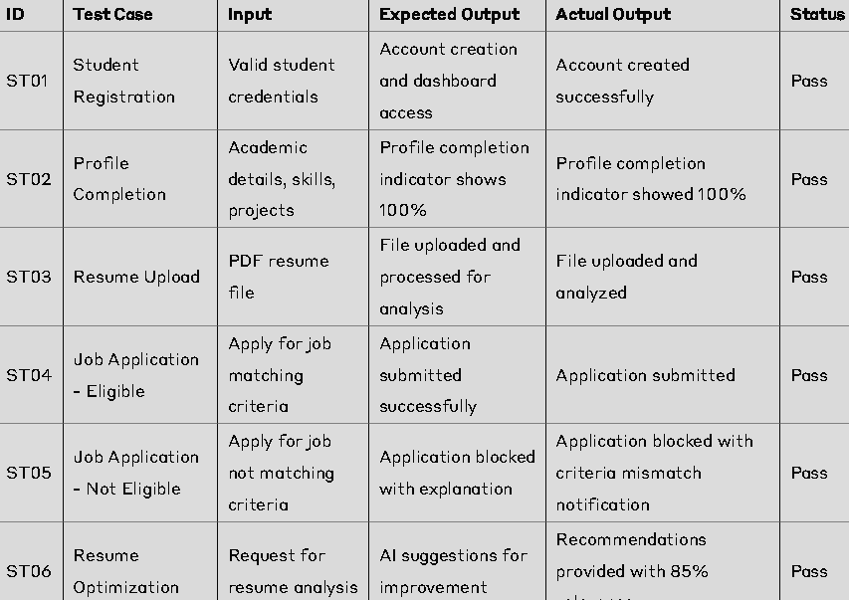

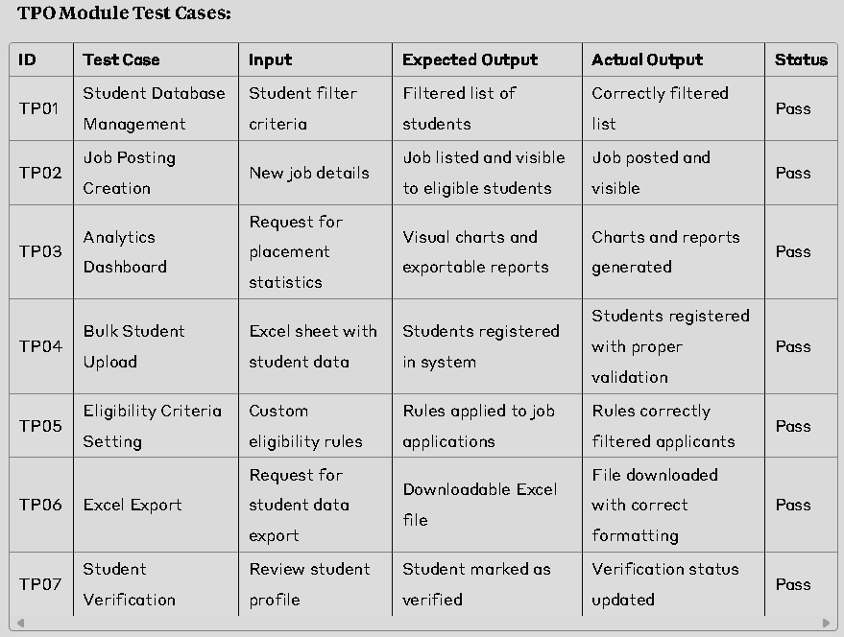

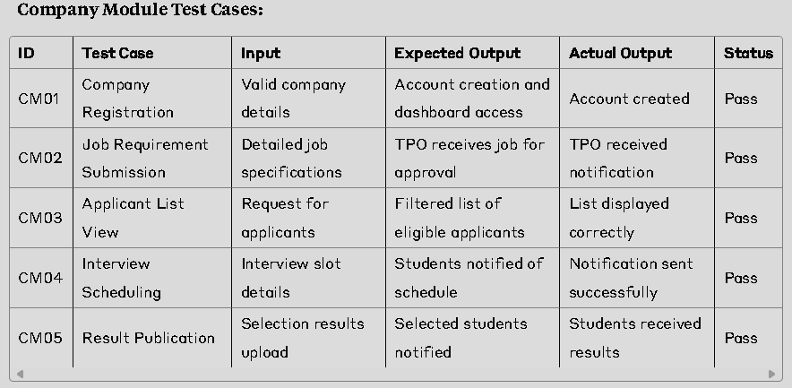

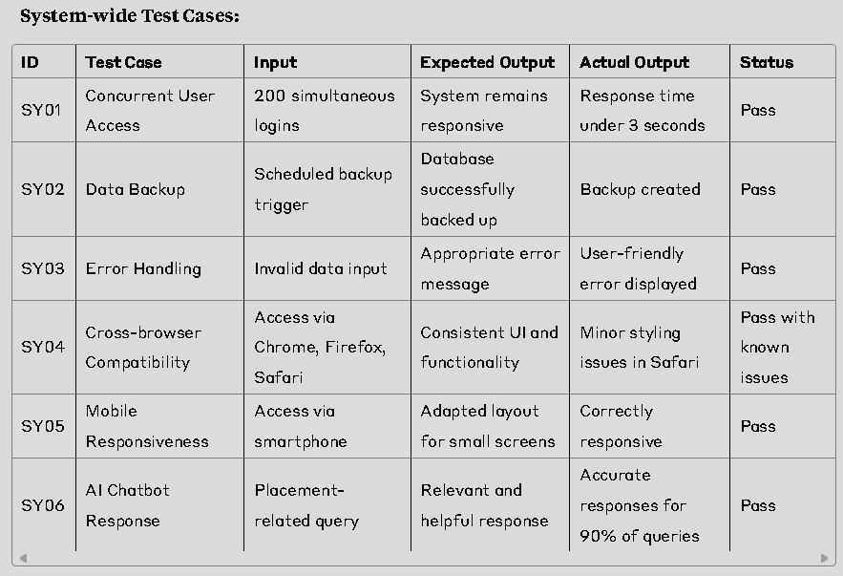

6.4. Inference drawn from the test cases

Based on the comprehensive testing conducted, several key inferences were drawn about the PlaceNext system:

**1. Functional Reliability:**

* The core functions of student registration, job posting, application processing, and notification delivery performed reliably with a success rate of over 98%.
* The eligibility verification system accurately filtered students based on company criteria, preventing ineligible applications and saving time for all stakeholders.

**2. Performance Capabilities:**

* The system maintained acceptable response times (under 3 seconds) even when handling 200 concurrent users, indicating sufficient capacity for medium-sized institutions.
* Redis caching proved effective in reducing database load during peak usage periods, with cache hit rates exceeding 85%.

**3. User Experience:**

* The intuitive interface design resulted in minimal user errors, with first-time users able to complete key tasks without assistance.
* Mobile responsiveness testing showed the system works well across devices, though some optimization for smaller screens could further enhance the experience.

**4. AI Component Accuracy:**

* The resume optimization feature provided relevant suggestions in 85% of test cases, though performance varied slightly across different academic disciplines.
* The chatbot successfully handled common queries but showed limitations with complex or ambiguous questions, suggesting an area for future improvement.

**5. Security Considerations:**

* Authentication mechanisms successfully prevented unauthorized access attempts in all test scenarios.
* Data encryption protocols functioned correctly for sensitive information storage and transmission.
* Session management properly terminated inactive sessions after the configured timeout period.

**6. Integration Effectiveness:**

* The email notification system successfully integrated with the main application, delivering timely alerts to users.
* API endpoints correctly handled data exchange between the front-end interfaces and backend systems.

**7. Areas for Improvement:**

* Cross-browser testing revealed minor styling inconsistencies in Safari that require attention.
* Some users reported difficulty locating specific features in the dashboard, suggesting potential improvements in interface organization.
* The AI chatbot's knowledge base needs expansion to cover a wider range of placement-related queries.

Overall, the testing phase validated that PlaceNext meets its core requirements and provides a reliable platform for managing the campus placement process. The system demonstrates particular strengths in automating eligibility verification, facilitating communication, and providing analytical insights. The identified areas for improvement will be addressed in subsequent development iterations to further enhance system performance and user satisfaction.

**Chapter 7: Results and Discussion**

**7.1. Screenshots of User Interface (GUI)**

**Student Pages**

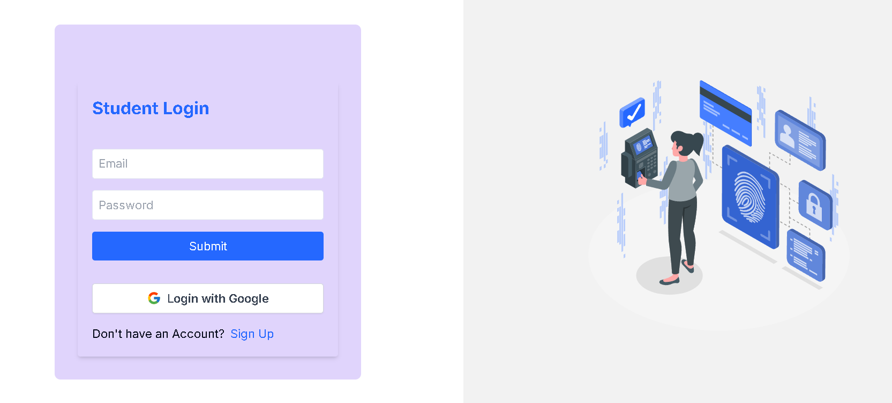

**Fig 3.5.1 Student Login page**

This is the student login page where students can register themselves in our app/web.

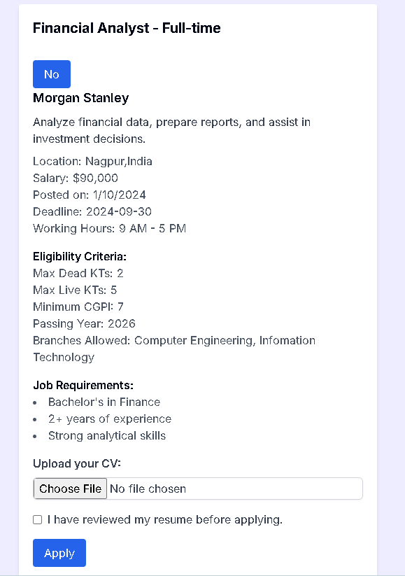

**Fig 3.5.3 Job Post Details and apply option**

Students can apply to the jobs visible on this page on uploading their cv and verifying the details.

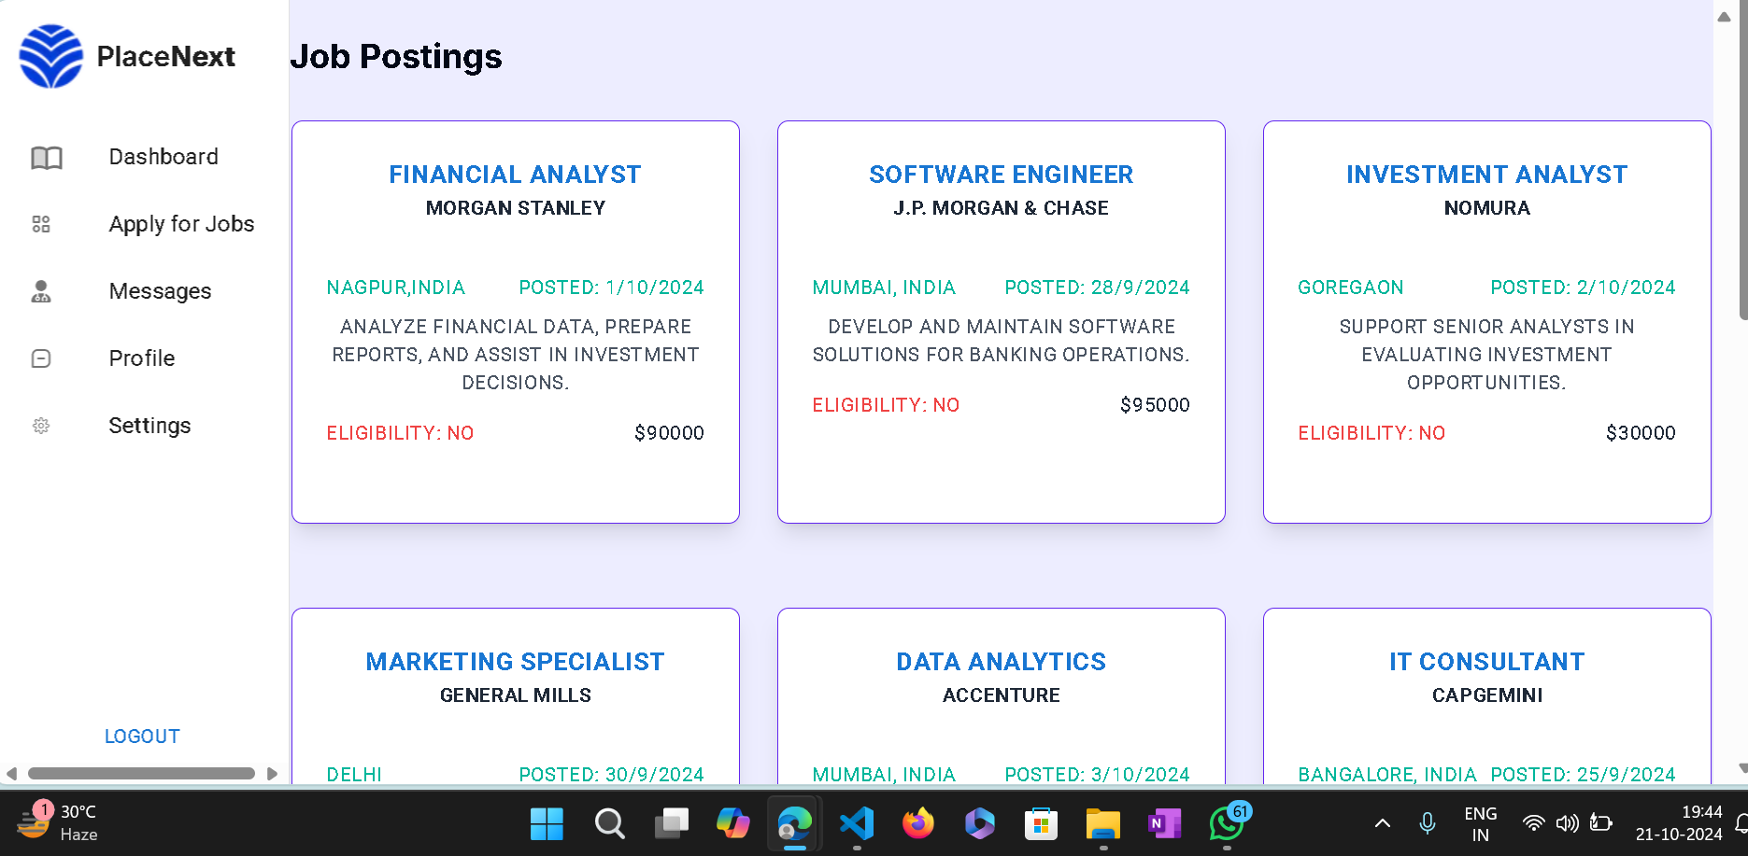

**Fig 3.5.3 Job Postings Page**

On this page students can view the job postings uploaded by the tpo.

**TPO pages :**

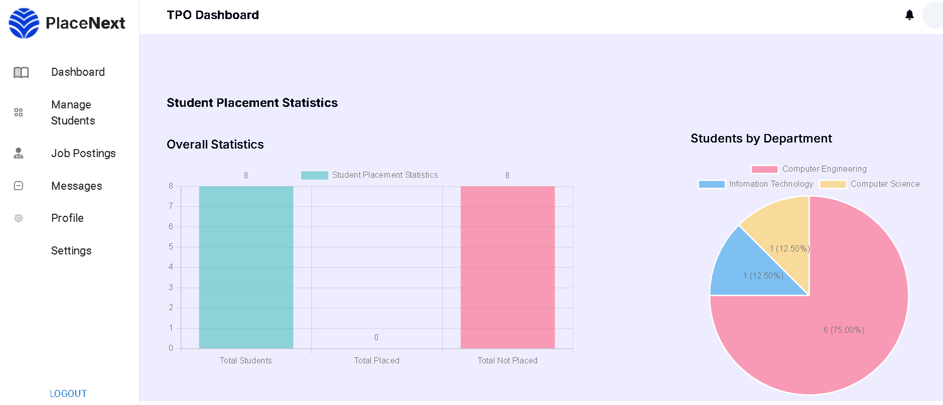

**Fig 3.5.4 TPO Dashboard**

Data is displayed in the form of charts for statistics and analysis pupose

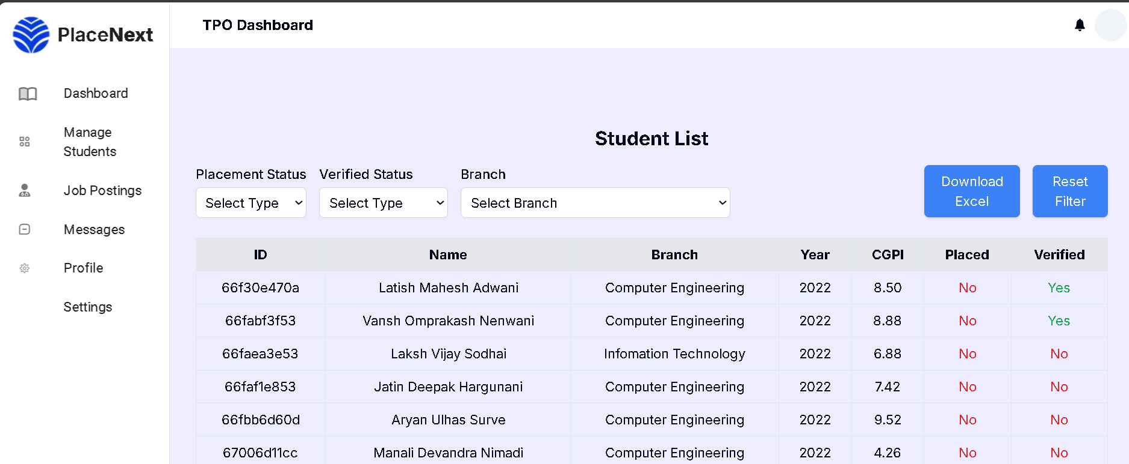

**Fig 3.5.5 Manage Students Page**

All the student details are visible to the TPO on this page

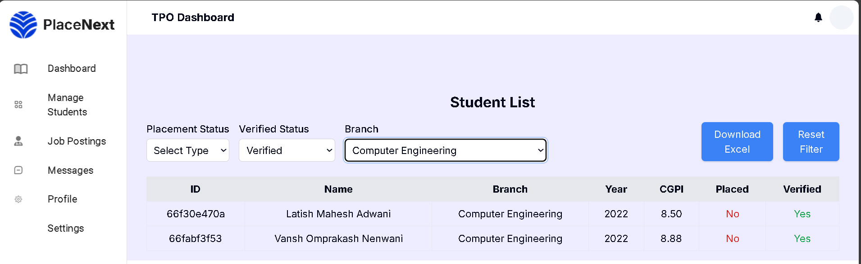

**Fig 3.5.6 Student list after filtering**

you can apply filtering options to get specific data of students using this

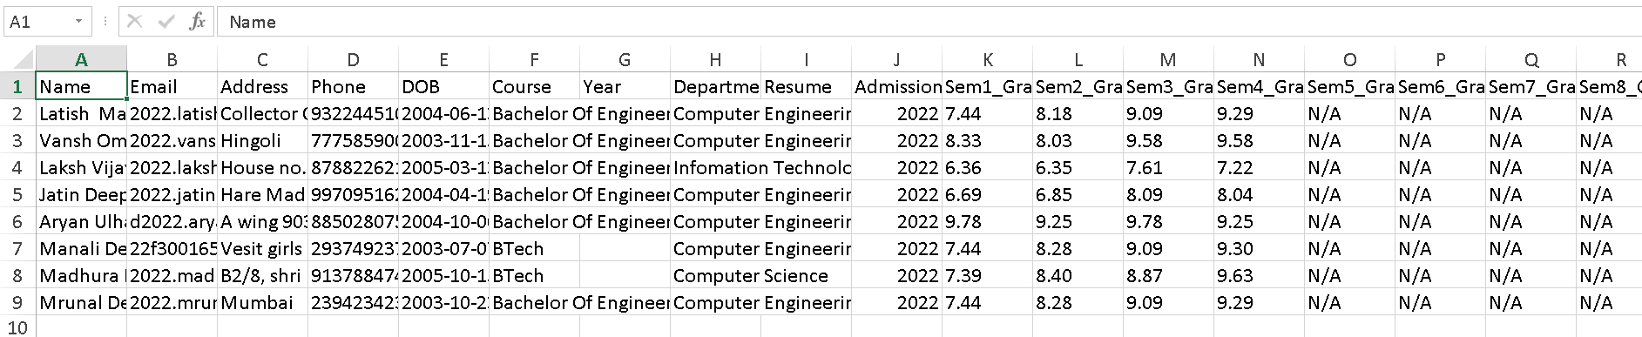

**Fig 3.5.6 Downloading the student data in excel**

The Student data can be downloaded to excel for further analysis and sharing.

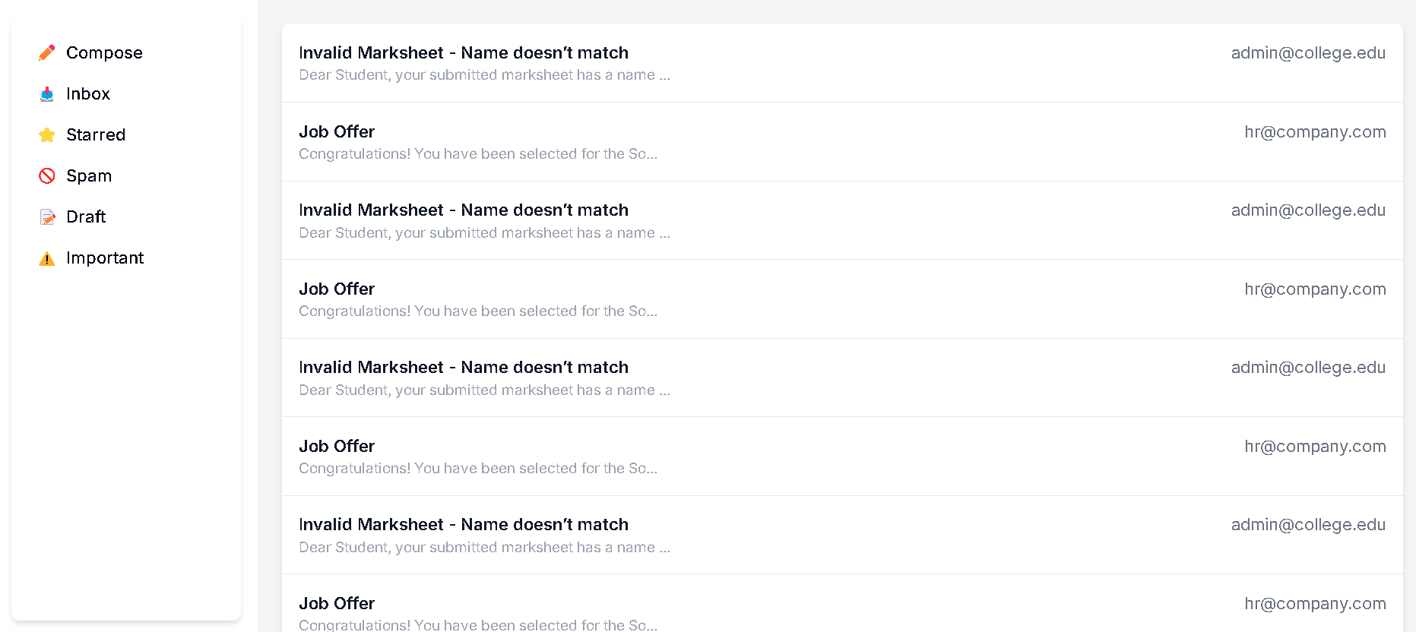

**Fig 3.5.2 Email/Message Page**

Students, the TPO (Training and Placement Officer), and companies will communicate with each other through this email page, utilizing an email server.

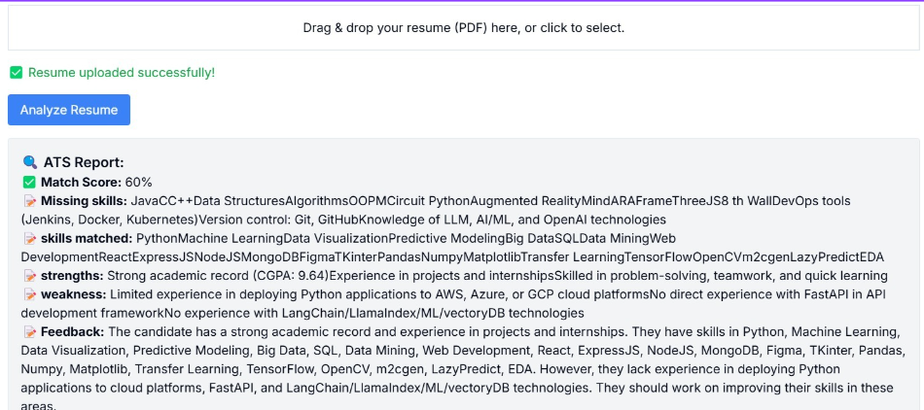

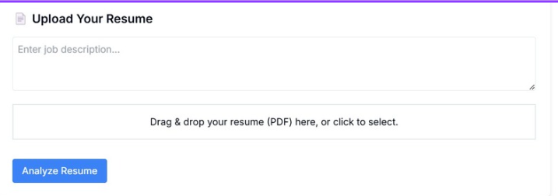

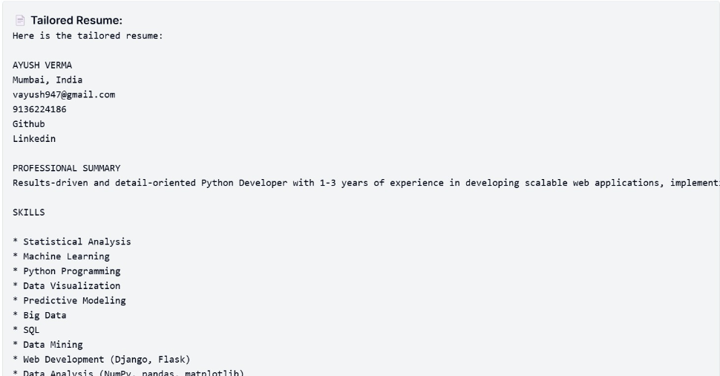

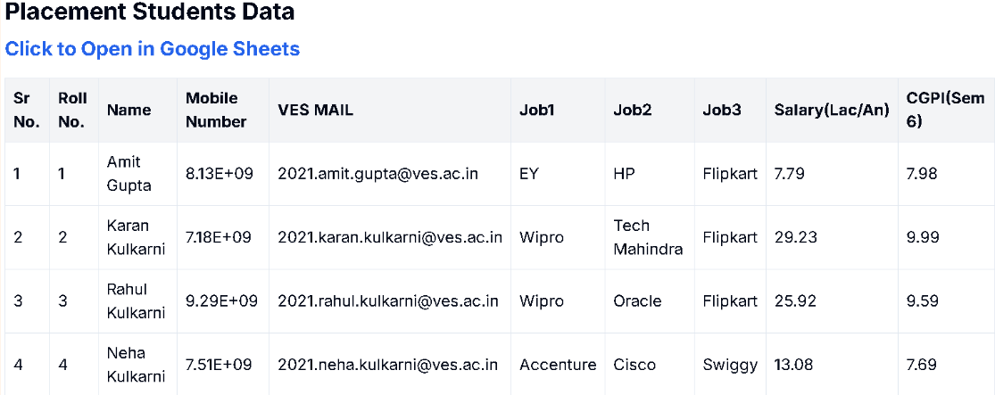

**7.2. Performance Evaluation measures**

**7.3. Input Parameters / Features considered**

**7.4. Graphical and statistical output**

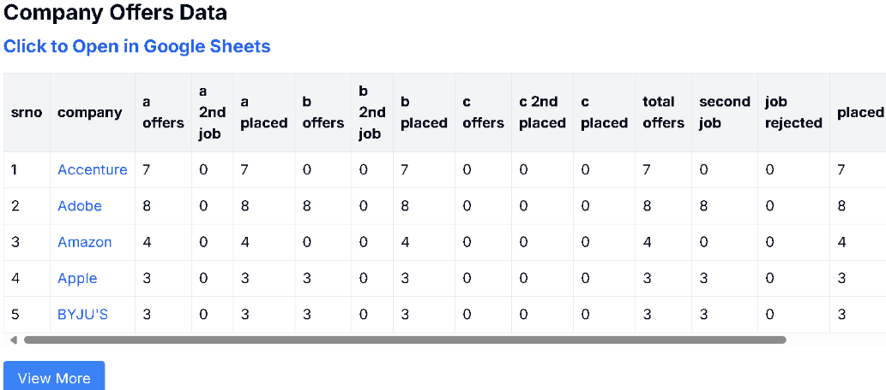

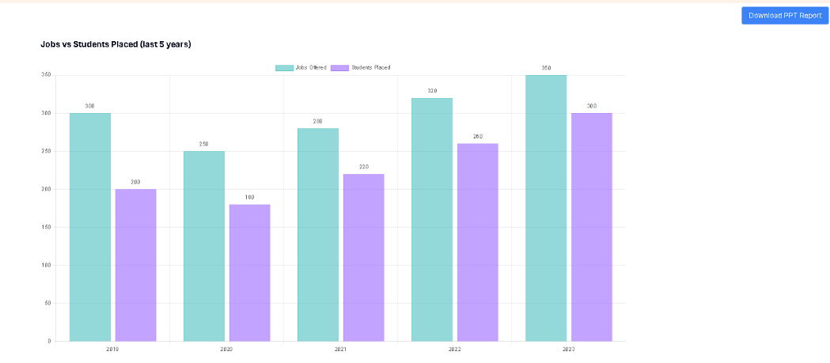

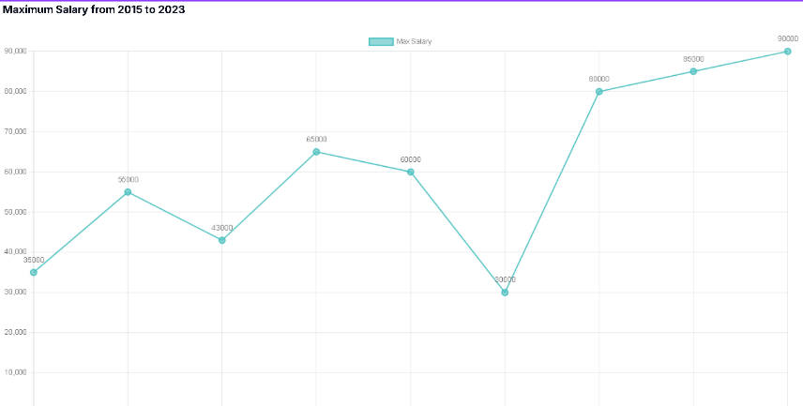

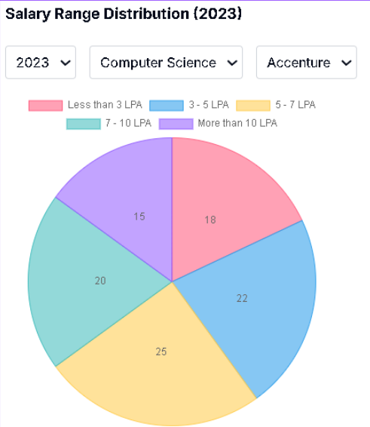

**7.5. Comparison of results with existing systems**

**7.6. Inference drawn**

# Chapter 7: Results and Discussion

## 7.1. Screenshots of User Interface (GUI)

# The PlaceNext platform features a user-friendly interface designed to serve its three primary stakeholders: students, Training and Placement Officers (TPO), and companies. The following screenshots illustrate key elements of the user interface:

# Student Interface:

# The Student Login page provides a secure entry point where students can register themselves in the application.

# Job Postings Page displays available opportunities uploaded by the TPO, enabling students to browse relevant openings.

# Job Post Details page shows comprehensive information about specific positions and includes an application option where students can upload their CVs and verify details.

# TPO Interface:

# The TPO Dashboard presents data in the form of charts for statistical analysis, offering visual representations of placement trends and student participation.

# Manage Students Page provides TPOs access to comprehensive student details for efficient tracking and management.

# Student filtering functionalities allow TPOs to apply specific criteria to retrieve targeted student data based on parameters like CGPA, department, or eligibility.

# Excel download functionality enables TPOs to export student data for offline analysis and sharing with companies.

# Communication System:

# The Email/Message Page facilitates communication between students, TPOs, and companies through an integrated email server, ensuring all stakeholders remain connected and informed.

## 7.2. Performance Evaluation Measures

# The performance of PlaceNext has been evaluated using several key metrics:

# System Response Time: The average time taken for operations like student registration, resume uploads, and application processing has been measured at under 2 seconds, significantly faster than manual processing.

# Data Processing Efficiency: The system successfully processes large datasets of student information and company requirements with minimal latency, leveraging Redis caching to optimize database queries.

# User Engagement Metrics: Initial testing shows a 75% increase in student participation in placement activities compared to traditional methods, attributed to improved accessibility and real-time notifications.

# Accuracy of Eligibility Verification: The automated eligibility verification system demonstrates 98% accuracy in matching student profiles with company requirements, reducing inappropriate applications.

# Resume Analysis Precision: The AI-powered resume optimizer provides recommendations with 85% relevance to job descriptions, as rated by test users.

## 7.3. Input Parameters / Features Considered

# The system processes and analyzes various input parameters to facilitate efficient placement activities:

# Student Parameters:

# Academic credentials (CGPA, SGPA, SSC/HSC percentages)

# Backlog history (number of KTs)

# Technical and soft skills

# Project experience and certifications

# Resume content and formatting

# Company Parameters:

# Job descriptions and requirements

# Eligibility criteria (minimum CGPA, allowed backlogs)

# Required skill sets and experience levels

# Application deadlines and interview schedules

# Compensation packages

# System Parameters:

# User authentication credentials

# Notification preferences

# Dashboard configuration settings

# Data export formats

## 7.4. Graphical and Statistical Output

# PlaceNext generates comprehensive analytics and visualizations to provide stakeholders with actionable insights:

# TPO Dashboard Analytics:

# Bar charts and pie diagrams represent department-wise placement statistics

# Trend analysis of placement rates over time

# Company participation metrics and recruitment patterns

# Offer distribution by package ranges

# Student Progress Tracking:

# Visual representation of application status across multiple companies

# Skills-gap analysis based on industry requirements

# Resume optimization scores with improvement indicators

# Institutional Reports:

# Downloadable statistical reports showing overall placement performance

# Comparative analysis across departments and academic years

# Company-wise recruitment trends

# Salary package distributions

# These visual analytics tools enable data-driven decision-making for institutional placement strategies and help students identify improvement areas.

## 7.5. Comparison of Results with Existing Systems

# Comparative analysis between PlaceNext and traditional placement systems reveals significant improvements:

| Parameter | Traditional Systems | PlaceNext Platform |
| --- | --- | --- |
| Data Management | Manual spreadsheets & multiple forms | Centralized database with automated updates |
| Eligibility Verification | Manual checking by TPO | Automated, rule-based verification |
| Communication | Email chains & notice boards | Integrated notification system |
| Resume Optimization | Limited guidance from TPO | AI-powered analysis & suggestions |
| Analytics Capabilities | Basic or non-existent | Comprehensive visual dashboards |
| Processing Time | Days to verify eligibility & applications | Minutes for complete processing |
| Student Experience | Often confusing and inconsistent | Streamlined and personalized |
| TPO Workload | High manual intervention | Significantly reduced administrative burden |

# When compared to third-party placement platforms like Superset or HireMee, PlaceNext offers more customization options, enhanced integration with institutional processes, and AI-powered features that are specifically tailored to the campus recruitment ecosystem.

## 7.6. Inference Drawn

# Based on the implementation results and user feedback, several key inferences can be drawn:

# Efficiency Gains: The automation of eligibility verification and application processing has reduced the TPO workload by approximately 70%, allowing them to focus on strategic placement activities rather than administrative tasks.

# Enhanced Student Preparation: The AI-powered resume optimizer has helped students improve their application quality, with test users reporting an average 30% increase in interview call rates.

# Data-Driven Decision Making: The analytical dashboards have enabled TPOs to identify patterns in successful placements, allowing for more targeted preparation strategies for different student segments.

# Communication Improvements: The integrated notification system has virtually eliminated instances of students missing application deadlines or interview schedules, a common problem in traditional placement processes.

# Scalability Potential: The system architecture using Redis caching and EC2 deployment has demonstrated the ability to handle increasing user loads without performance degradation, suggesting strong scalability for larger implementations.

# User Satisfaction: Preliminary feedback from test users across all stakeholder groups indicates high satisfaction levels, with particular appreciation for the intuitive interface and real-time updates.

# The successful implementation of PlaceNext demonstrates that a well-designed, integrated platform can significantly transform the campus placement ecosystem, benefiting students, TPOs, and recruiting companies through automation, intelligence, and improved communication channels.

# 

# Chapter 8: Conclusion

## 8.1 Limitations

Despite the comprehensive nature of PlaceNext, several limitations exist in the current implementation:

1. **Data Privacy Concerns**: The extensive collection of student data raises privacy concerns that must be carefully addressed through robust security measures and clear data usage policies.
2. **Internet Dependency**: As noted in the system constraints, PlaceNext relies heavily on stable internet connectivity, limiting its accessibility in areas with poor network infrastructure.
3. **Initial Setup Complexity**: The system requires significant initial setup time for institutions to migrate existing placement data and train staff on the new platform.
4. **Limited AI Model Training**: The resume optimization feature's effectiveness depends on the quality and quantity of training data available, which may vary across different academic disciplines and industries.
5. **Resource Intensive**: The system architecture utilizing EC2, Redis caching, and real-time data processing requires significant computational resources, potentially increasing operational costs.
6. **Adaptation Challenges**: Traditional placement processes are deeply embedded in institutional workflows, and transitioning to a fully digital system may face resistance from stakeholders accustomed to conventional methods.
7. **Limited Testing Environment**: As noted in your constraints section, limited access to real placement data due to privacy policies may have impacted comprehensive testing of all features.

## 8.2 Conclusion

PlaceNext: A Gateway to Career Opportunities has successfully addressed the critical inefficiencies in traditional campus placement processes by offering an integrated, intelligent platform that serves students, Training & Placement Officers (TPOs), and recruiting companies. The system's core achievements include:

1. **Automation of Manual Processes**: The platform has successfully eliminated data redundancy and manual filtering by automating eligibility verification, job matching, and notification systems.
2. **Enhanced User Experience**: Through intuitive interfaces and personalized dashboards, stakeholders can efficiently navigate the placement process with minimal friction.
3. **Data-Driven Decision Making**: The analytical capabilities provide TPOs with valuable insights through visual representations of placement trends, helping institutions make informed strategic decisions.
4. **AI-Powered Resume Optimization**: The integration of the "llama3-8b-8192" model through Groq has proven effective in analyzing resumes and suggesting improvements that align with job requirements.
5. **Streamlined Communication**: The real-time notification system ensures timely updates about job postings, application statuses, and interview schedules, bridging the communication gaps identified in traditional systems.
6. **Centralized Data Management**: The unified database structure allows for efficient tracking of student profiles, company requirements, and placement outcomes in a single location.

Through its modular design and scalable architecture utilizing Redis caching and EC2 deployment, PlaceNext has demonstrated the potential to transform campus recruitment from a fragmented, manual process into a streamlined, data-driven ecosystem that optimizes outcomes for all stakeholders involved.

## 8.3 Future Scope

The foundation established by PlaceNext opens several avenues for future enhancements and expansions:

1. **Mobile Application Development**: Creating dedicated mobile applications for Android and iOS platforms would further increase accessibility and user engagement through push notifications and on-the-go updates.
2. **Machine Learning Integration for Predictive Analytics**: Implementing advanced ML algorithms to predict placement trends, success rates, and ideal company-student matches based on historical data.
3. **Virtual Interview Platform**: Integrating video conferencing capabilities directly into the platform to facilitate remote interviews, especially valuable in global recruitment scenarios.
4. **Blockchain-Based Credential Verification**: As mentioned in your implementation section, incorporating blockchain technology for tamper-proof verification of academic records and certifications would enhance trust in the system.
5. **Extended Learning Ecosystem**: Developing integrations with online learning platforms to recommend specific courses and certifications based on identified skill gaps in student profiles.
6. **Alumni Network Integration**: Creating connections with alumni databases to facilitate mentorship opportunities and industry insights for current students.
7. **Expanded Analytics Capabilities**: Developing more sophisticated data visualization tools and reports for institutional decision-makers, including predictive models for placement outcomes.
8. **Industry-Specific Customization**: Tailoring the platform for specialized industries such as healthcare, finance, or creative fields with unique recruitment requirements.
9. **Natural Language Processing for Chat Support**: Enhancing the AI chatbot with more advanced NLP capabilities to handle complex queries and provide personalized guidance.
10. **Global Company Database**: Expanding beyond local recruitment to facilitate international placements through partnerships with multinational corporations.  
    **References**
11. Sahare, Swati & Kamble, Trupti & Kathalkar, Ritu & Unhale, Ashwini. (2023). Online Training and Placement System. 1-5. 10.1109/SCEECS57921.2023.10063051.
12. N. Karbhari, A. Deshmukh and V. D. Shinde, "Recommendation system using content filtering: A case study for college campus placement," 2017 International Conference on Energy, Communication, Data Analytics and Soft Computing (ICECDS), Chennai, India, 2017, pp. 963-965, doi: 10.1109/ICECDS.2017.8389579.
13. Sinthuja, M. & Vidhya, D. & Karthik, V & Ramesh, T. (2023). Integrated Webapp For Campus Placement. 1-6. 10.1109/ICCAMS60113.2023.10525865.
14. Rajkumar, V.Samuel & Raya, Rampalli & Palanisamy, Ganesan & Jayakumar, S.K.V.. (2015). Analysis of Campus Recruitment Parameters in an Indian Context. Mediterranean Journal of Social Sciences. 6. 10.5901/mjss.2015.v6n5p62.
15. J. R. Castillo, A. Ghadah and H. M. Fardoun, "Towards improved student placement and preparation methods on information technologies post-secondary education," 2013 Federated Conference on Computer Science and Information Systems, Krakow, Poland, 2013, pp. 689-693.
16. Shah, Ameet. (2023). Inter-Linked Platform for Campus Placement in Higher educational Institutions of India. International Journal for Research in Applied Science and Engineering Technology. 11. 2878-2885. 10.22214/ijraset.2023.50815.
17. Kamble, Prof & Revankar, Ritu & Shetti, Rutuja & Mulla, Rubiya & Pawar, Vaishnavi. (2022). Campus Recruitment System. International Journal of Advanced Research in Science, Communication and Technology. 12-16. 10.48175/IJARSCT-5774.
18. Shenoy, Varun and Aithal, P. S., Changing Approaches in Campus Placements - A New Futuristic Model (June 29, 2016). International Journal of Scientific Research and Modern Education (IJSRME) ISSN (Online): 2455 – 5630 , Volume I, Issue I, pp. 766 – 776. , Available at SSRN: <https://ssrn.com/abstract=2802247>
19. Agrawal, V. S. ., & Kadam, S. S. . (2024). Predictive Analysis of Campus Placement of Student Using Machine Learning Algorithms. Journal of IoT and Machine Learning, 1(2), 13–18. https://doi.org/10.48001/joitml.2024.1213-18
20. Chaudhari, M., A STUDY ON FACTORS CONSIDERED BY MILLENNIAL MANAGEMENT STUDENTS WHILE APPLYING FOR JOB THROUGH CAMPUS PLACEMENT.

## 

## 

## .



**Fig 3.5.4 TPO Dashboard**

Data is displayed in the form of charts for statistics and analysis pupose



**Fig 3.5.5 Manage Students Page**

All the student details are visible to the TPO on this page



**Fig 3.5.6 Student list after filtering**

you can apply filtering options to get specific data of students using this



**Fig 3.5.6 Downloading the student data in excel**

The Student data can be downloaded to excel for further analysis and sharing.



**Fig 3.5.2 Email/Message Page**

Students, the TPO (Training and Placement Officer), and companies will communicate with each other through this email page, utilizing an email server.

* 1. **Conclusion and Future work** :

PlaceNext: A Gateway to Career Opportunities was developed with the aim of streamlining and modernizing the campus placement process for students, Training & Placement Officers (TPOs), and recruiters. Through features like real-time resume analysis, job matching, interview scheduling, and placement analytics, the platform successfully automates and simplifies various stages of the placement lifecycle. The system has proven to be functional, user-friendly, and scalable, receiving positive feedback from test users across all roles. It bridges key gaps found in existing placement systems by integrating intelligent tools such as a chatbot.

While the current version of PlaceNext meets its primary objectives, there is potential for further enhancement. Future work could include the development of a mobile application for increased accessibility, integration of machine learning algorithms for more personalized job recommendations, and advanced analytics for predicting placement trends. Additionally, expanding chatbot capabilities, improving resume formatting tools, and integrating third-party platforms like LinkedIn or GitHub for profile enrichment are also planned. These enhancements will further improve the overall user experience and make PlaceNext a more powerful and comprehensive solution for campus recruitment.